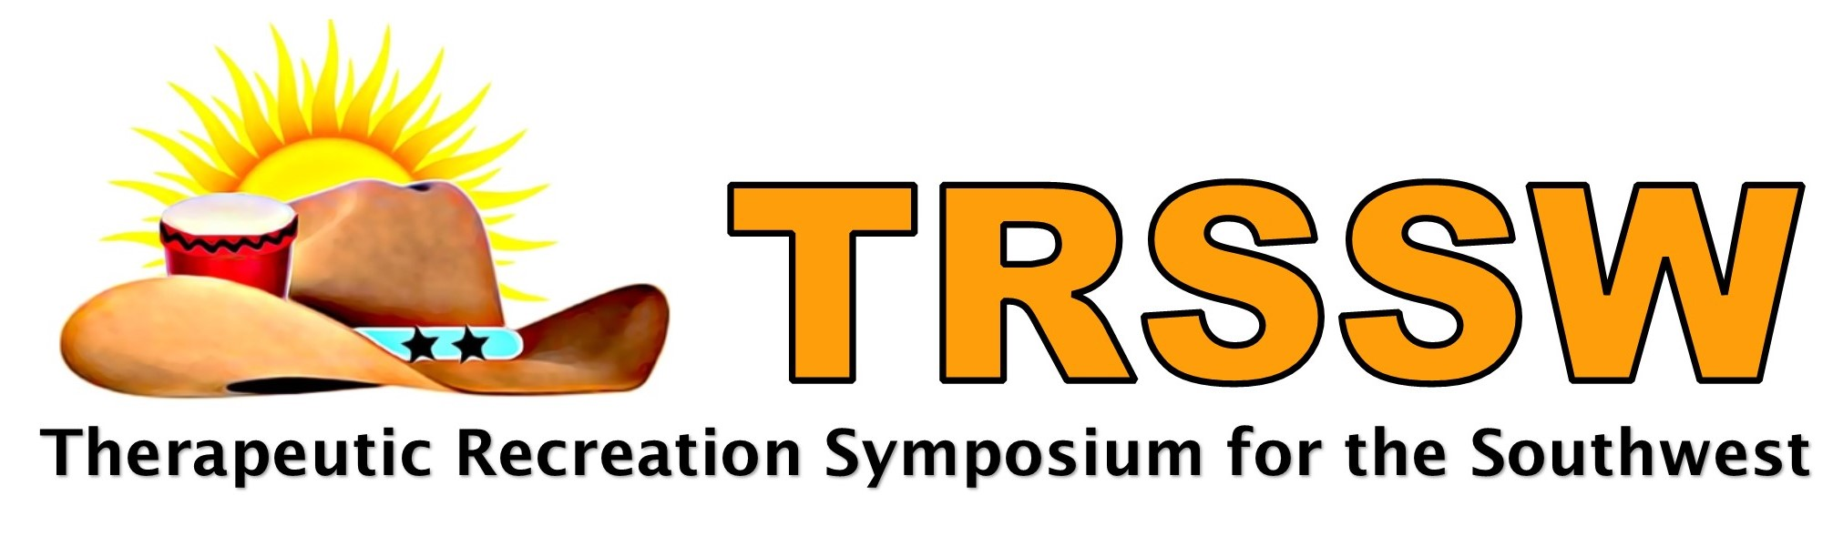
COMING BACK sTRonger

Pre-Symposium
1:00 pm-5:30 pm, Wednesday, November 9th 2022
General Symposium
8:30 am Thursday, November 10th – 5:30 pm Friday, November 11th, 2022
T. Boone Pickens Training and Conference Center
Scottish Rite for Children, 2222 Welborn Street, Dallas, TX 75219

First Name: __________________________________ Last Name: ______________________________________

Organization: __________________________________________________________________________________

Mailing Address: _______________________________________________________________________________

Phone: ____________________ Email: _____________________________________________

Special Accommodations: ________________________________________________________

Dietary Needs _______________________________________________________________

BADGE INFORMATION (how your information will appear on your badge)

Full Name on Badge: ____________________________________________________________

Credentials: __________________________________________________________________

City: ___________________________________ State: _______________________________

Would you like your contact information (Name, Organization, Phone and Email) placed on a networking list to be shared only with fellow TRSSW 2022 attendee’s? Yes _____ No ____

TRSSW Registration Fees (Please check the appropriate fees or credits)

Pre-Symposium – November 9, 2022
___ Pre-Symposium  Includes session and CEUs | $65
Full Registration - November 10 & 11,2022
___ Early Bird Full Professional Symposium (Postmarked by October 13, 2022)  Includes sessions, continental breakfasts (2), lunches (2), snacks, and CEUs | $250
___ Full Professional Symposium (Postmarked AFTER October 13, 2022)  Includes sessions, continental breakfasts (2), lunches (2), snacks, and CEUs | $299
Daily Registration
___ Early Bird Professional One Day --check day ____Thurs (11/10) ____ Friday (11/11)  (Postmarked by October 13, 2022) Includes sessions, continental breakfast, lunch,  snacks, and CEUs | $165/day
___ Professional One Day --check day ____Thurs (11/10) ____ Friday (11/11)  (Postmarked AFTER October 13, 2022) Includes sessions, continental breakfast, lunch,  snacks, and CEUs | $199/day
SPEAKER (need only register if you are attending more than your own session)
___ Speaker Credit ($50 credit per 1.5 hour session presented, to be divided between speakers)  Please enter amount credited to this registration and subtract from total payment due)  Name of Co-Presenter, if any______________________________________ | $( )
Student Registration with volunteer assignment
___ Early Bird Full Student Symposium (Postmarked by October 13, 2022)  Includes sessions, continental breakfasts (2), lunches (2), snacks, and CEUs | $50
___ Full Student Symposium (Postmarked AFTER October 13, 2022)  Includes sessions, continental breakfasts (2), lunches (2), snacks, and CEUs | $100
___ Early Bird Student One Day --check day ____Thurs (11/10) ____ Friday (11/11)  (Postmarked by October 13, 2022) Includes sessions, continental breakfast, lunch,  snacks, and CEUs | $35/day
___ Student One Day --check day ____Thurs (11/10) ____ Friday (11/11)  (Postmarked AFTER October 13, 2022) Includes sessions, continental breakfast, lunch,  snacks, and CEUs | $50/day
Total Amount Due | $

Fees MUST accompany registration
Make checks payable to Therapeutic Recreation Symposium for the Southwest (TRSSW)
Mail Registration with Payment to:
Erin Fogarty, 2120 Harvest Way, Mansfield TX, 76063

All cancellations must be received via email to TRSSW1@gmail.com
- If you are unable to attend, we encourage you to send a substitute, by sending a substitute no fees will be assessed.
- Symposium fees for emailed cancellations received on or before October 11, 2022, will be receive a refund minus a 50% cancellation fee. The symposium fee may be applied toward a future TRSSW symposium within one year, if the 50% refund is not requested.
- Symposium fees for emailed cancellations received after October 11, 2022, will not be refunded, but can be applied toward a future TRSSW symposium within one year.

