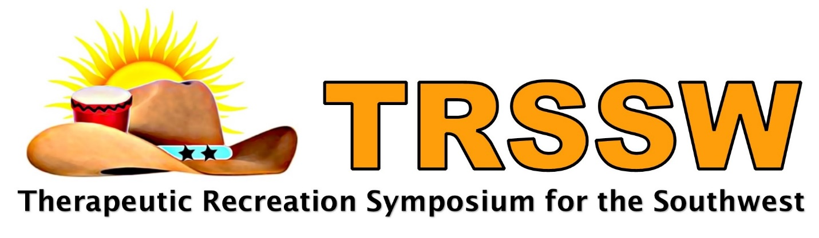

TRSSW Cancellation and Refund Policies:

- Full payment of the TRSSW fee is due by November 1, 2022, if fees are not received by November 1, the associated registration may be canceled.

- The Therapeutic Recreation Symposium for the Southwest (TRSSW) is designed to promote high quality learning experiences at reasonable costs. While schedules change, and emergencies unfortunately occur, when reservations are cancelled, particularly close to the event date, financial resources are expended, the cost of which are often difficult if not impossible to recoup. Therefore, refunds for cancelling participation in the TRSSW symposium will only be provided in accordance with these policies. All cancellations must be received via email to TRSSW1@gmail.com

  - If you are unable to attend, we encourage you to send a substitute, by sending a substitute no fees will be assessed. Please notify us of the change at: TRSSW1@gmail.com
  - Symposium fees for emailed cancellations received on or before October 11, 2022, will receive a refund minus a 50% cancellation fee. The symposium fee may be applied toward a future TRSSW symposium within one year, if the 50% refund is not requested.
  - Symposium fees for emailed cancellations received after October 11, 2022, will not be refunded, but can be applied toward a future TRSSW symposium within one year.

