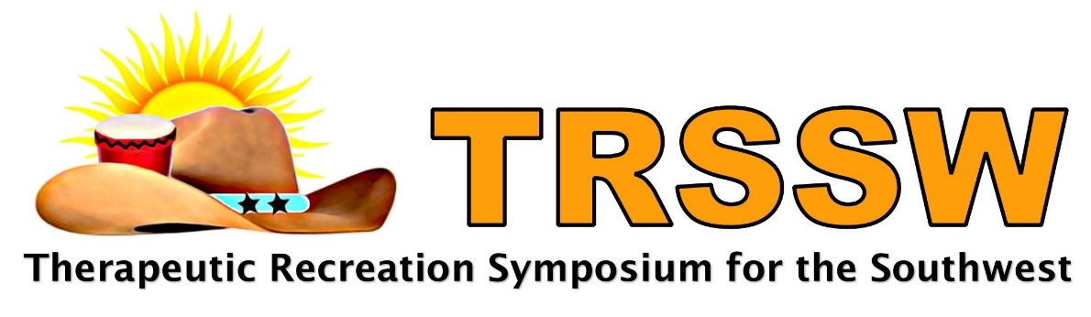
From its beginning in 1980, the Therapeutic Recreation Symposium for the Southwest (TRSSW) has grown into a nationally recognized organization. Its mission includes:
- presenting affordable opportunities to advance professional development for therapeutic recreation personnel
- provide educational assistance through scholarships for undergraduate and graduate students majoring in therapeutic recreation
- and recognizing outstanding contributions to the profession

Drawing over 100 attendees from the five state region (Arkansas, Louisiana, New Mexico, Oklahoma, and Texas) therapeutic recreation professionals, educators, park and recreation professionals, and students gather to expand their knowledge and enjoy networking. The Symposium sharpens the skills of those who serve individuals with disabilities so that quality of life is enhanced through recreation and leisure involvement.

Exhibiting sponsorships, underwriting, and advertising opportunities exist so that you can get recognition for your Company among an important profession that influences decisions made by consumers with disabilities.

Exhibiting Sponsorship Levels

  - $2,500 Champion Exhibiting Sponsor – *Three (3) symposium registrations *Recognition on all Symposium marketing materials including Company logo linking to your website on event webpage *Company recognized as the Champion Sponsor during awards luncheon *Invitation to awards luncheon with opportunity to present scholarship to the winner, including photo with winner and Board member *Signage recognizing Company at registration table and in awards luncheon *Company recognition in Symposium program *Unique opportunity to market your product/services directly to attendees * 6 foot draped table, two chairs, electrical power included in prime exhibit area *Right of first refusal for “The 2020 TRSSW Symposium”.

  - $1,000 Mentor Exhibiting Sponsor – *One (1) symposium registration *Company recognized as a Mentor Sponsor during awards luncheon *Invitation to awards luncheon *Signage recognizing Company at registration table and in awards luncheon *Company recognition in Symposium program *Unique opportunity to market your product/services directly to attendees * 6 foot draped table and two chairs included in prime exhibit area.
  - $500 Professional Exhibiting Sponsor – *Company recognized as a Professional Sponsor during awards luncheon *Invitation to awards luncheon *Signage recognizing Company at registration table and in awards luncheon *Company recognition in Symposium program *Unique opportunity to market your product/services directly to attendees * 6 foot draped table and two chairs included in prime exhibit area.

Underwriting and Advertising Levels

  - $300 Food/Beverage Advertising Level – *Underwrites a portion of cost for food/beverage during breaks *Company signage at food/beverage tables during breaks *Company recognition in Symposium program *Company materials you provide placed in attendee tote bags *Unique opportunity to market your product/services directly to attendees * 6 foot draped table and two chairs included in prime exhibit area.

- $150 Silent Auction Advertising Level – *Underwrites cost of basket contents used to raise funds for scholarships *Company recognition on gift basket *Company recognition in Symposium program *Company materials you provide placed in attendee tote bags *Unique opportunity to market your product/services directly to attendees * 6 foot draped table and two chairs included in prime exhibit area.

- $100 Advertising Level - * Unique opportunity to market your product/services directly to attendees by having Company materials you provide placed in attendee tote bags * 6 foot draped table and two chairs included in prime exhibit area.

- $50 Advertising Level - * Unique opportunity to market your product/services directly to attendees by having Company materials you provide placed in attendee tote bags.

- Product Donations - * Company recognition in Symposium program

November 13-15, 2019

Hosted by
Texas Scottish Rite Hospital for Children
2222 Welborn Street
Dallas, TX 75219

